8. PO/Requisition Menu: R. Reports Menu: 7. Purchase Order Labels

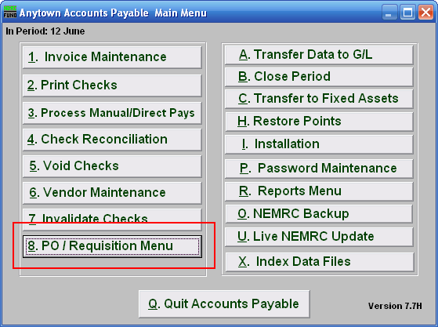
Click on “8. PO / Requisition Menu” from the Main Menu and the following window will appear:

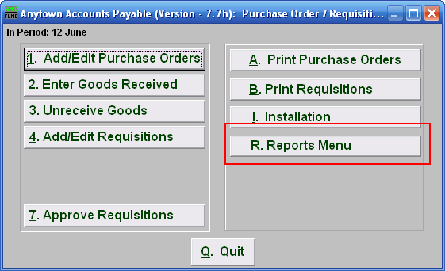
Click on “R. Reports Menu” from the Purchase Order / Requisition Menu and the following window will appear:

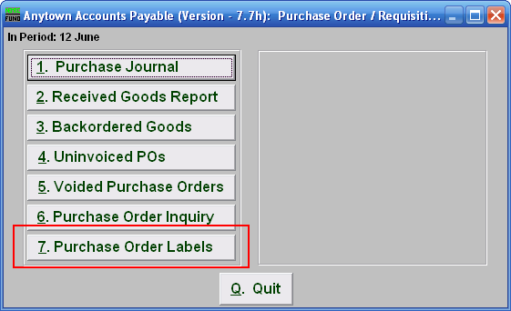
Click on “7. Purchase Order Labels” from the Purchase Order / Requisition’s Reports Menu and the following window will appear:

Purchase Order Labels

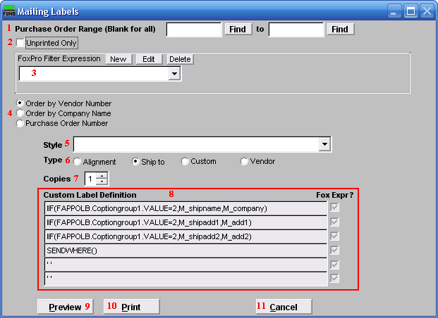
- Purchase Order Range (Blank for All): Enter the Purchase Order Number to start with and end with OR click on “Find” and select from there. Leave Blank if you want to include all Purchase Orders.

- Unprinted Only: Click here if you want to print labels for unprinted Purchase Orders only. Purchase orders are updated as printed only after the process of Print Purchase Order has been performed.

- FoxPro Filter Expression: A conditional reporting expression developed with NEMRC support. This evaluates purchase order information to determine if the Purchase Order should be included. Contact NEMRC support to learn more about this option.

- Order by Vendor OR Company Name OR Purchase Order Number: Select which order you want the labels to print in.

- Style: Click on the drop down arrow and choose the style of label that you want.

- Type: Select the Type of Label.

- Copies: Determine how many of each label you would like generated. This can be used for a mailing label, return address label and notice label in a three piece mailing.

- Custom Label Definition: Call NEMRC for details on how to achieve what you are looking for on the labels.

- Preview: Click this button to preview this report. Refer to GENERAL PREVIEW for more information.

- Print: Click this button to print the labels. Refer to GENERAL PRINTING for more information.

- Cancel: Click “Cancel” to cancel and return to the previous screen.

